Ceistneoir Sláinte
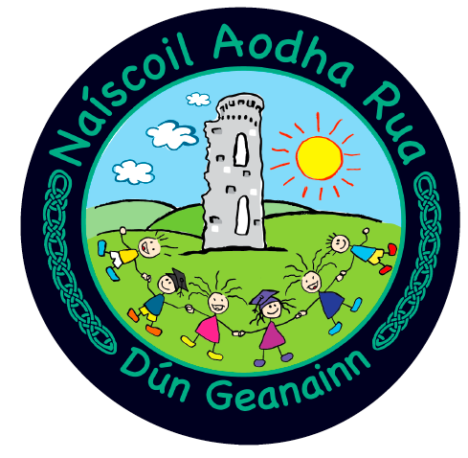
Health Questionnaire
The safety of our pupils, staff and their respective families remains our overriding priority, therefore we are restricting visitors to our setting at this time. Where a visit to our setting is deemed as ‘essential’, we respectfully ask all visitors to cooperate with our visitor protocols, including the ‘Health Questionnaire’ below:

Thank you for cooperation in supporting us in keeping our setting and our community safe and in supporting us to facilitate un-interrupted face to face learning for our pupils.

Visitor’s Name: |  | Contact Number:
Company: |  | Purpose of visit:
Temperature on arrival: |  | School Contacts (people in contact with during visit)
Self-Declaration by Visitor
1 | Have you or anyone in your household tested positive for Covid-19 within the last 10 days?  Yes No
2 | Have you or anyone in your household experienced symptoms of Covid-19 within the last 10 days? (fever, cough, sore throat, respiratory illness, difficulty breathing or loss of taste or smell)  Yes No
3 | Have you returned from another country within the last 14 days?  Yes No
4 | Have you had close contact with or cared for someone diagnosed with COVID-19 within the last 10 days?  Yes No
5 | Have you received a notification via the StopCOVID NI contact tracing app (or track and trace services) informing you that you have been a close contact of someone with Covid-19 within the last 10 days?  Yes No

If the answer is YES to any of these questions you will not be able to enter the school building.

Signature Date:
(staff member who carried out the questionnaire)

